**NAME:GANJAI SAI KUMAR**

**ID:700729622**

**Human Activity Detection - Results**

Ist Screen:

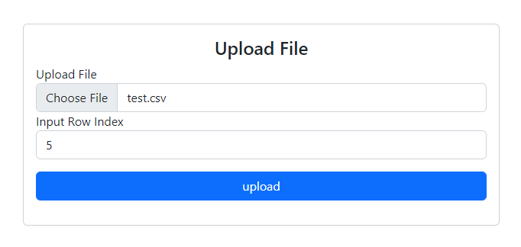

IInd Screen:

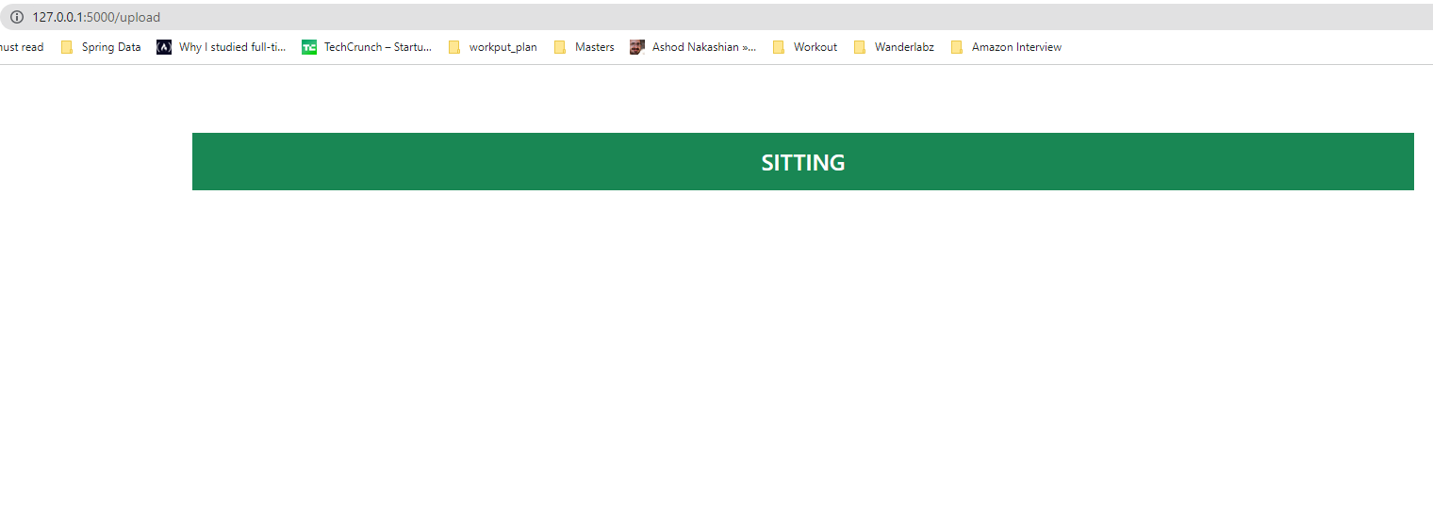

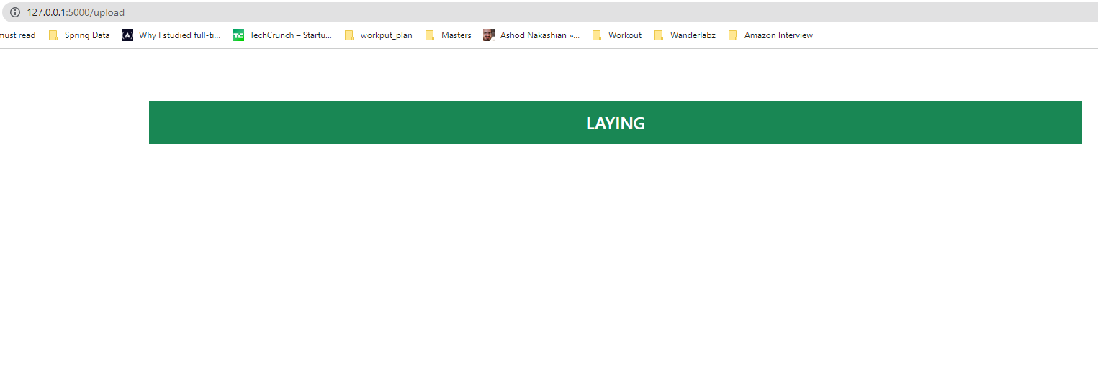

Log Output:

